VBDGS LLC • LEGAL CASE SUITE
PE Proper
Product Experience, Feature Assessment & Marketing Guide
A hands-on review using a fictional 5.8-year marriage, 19 household assets, gifts, separate property, sale proceeds, and professional report generation.
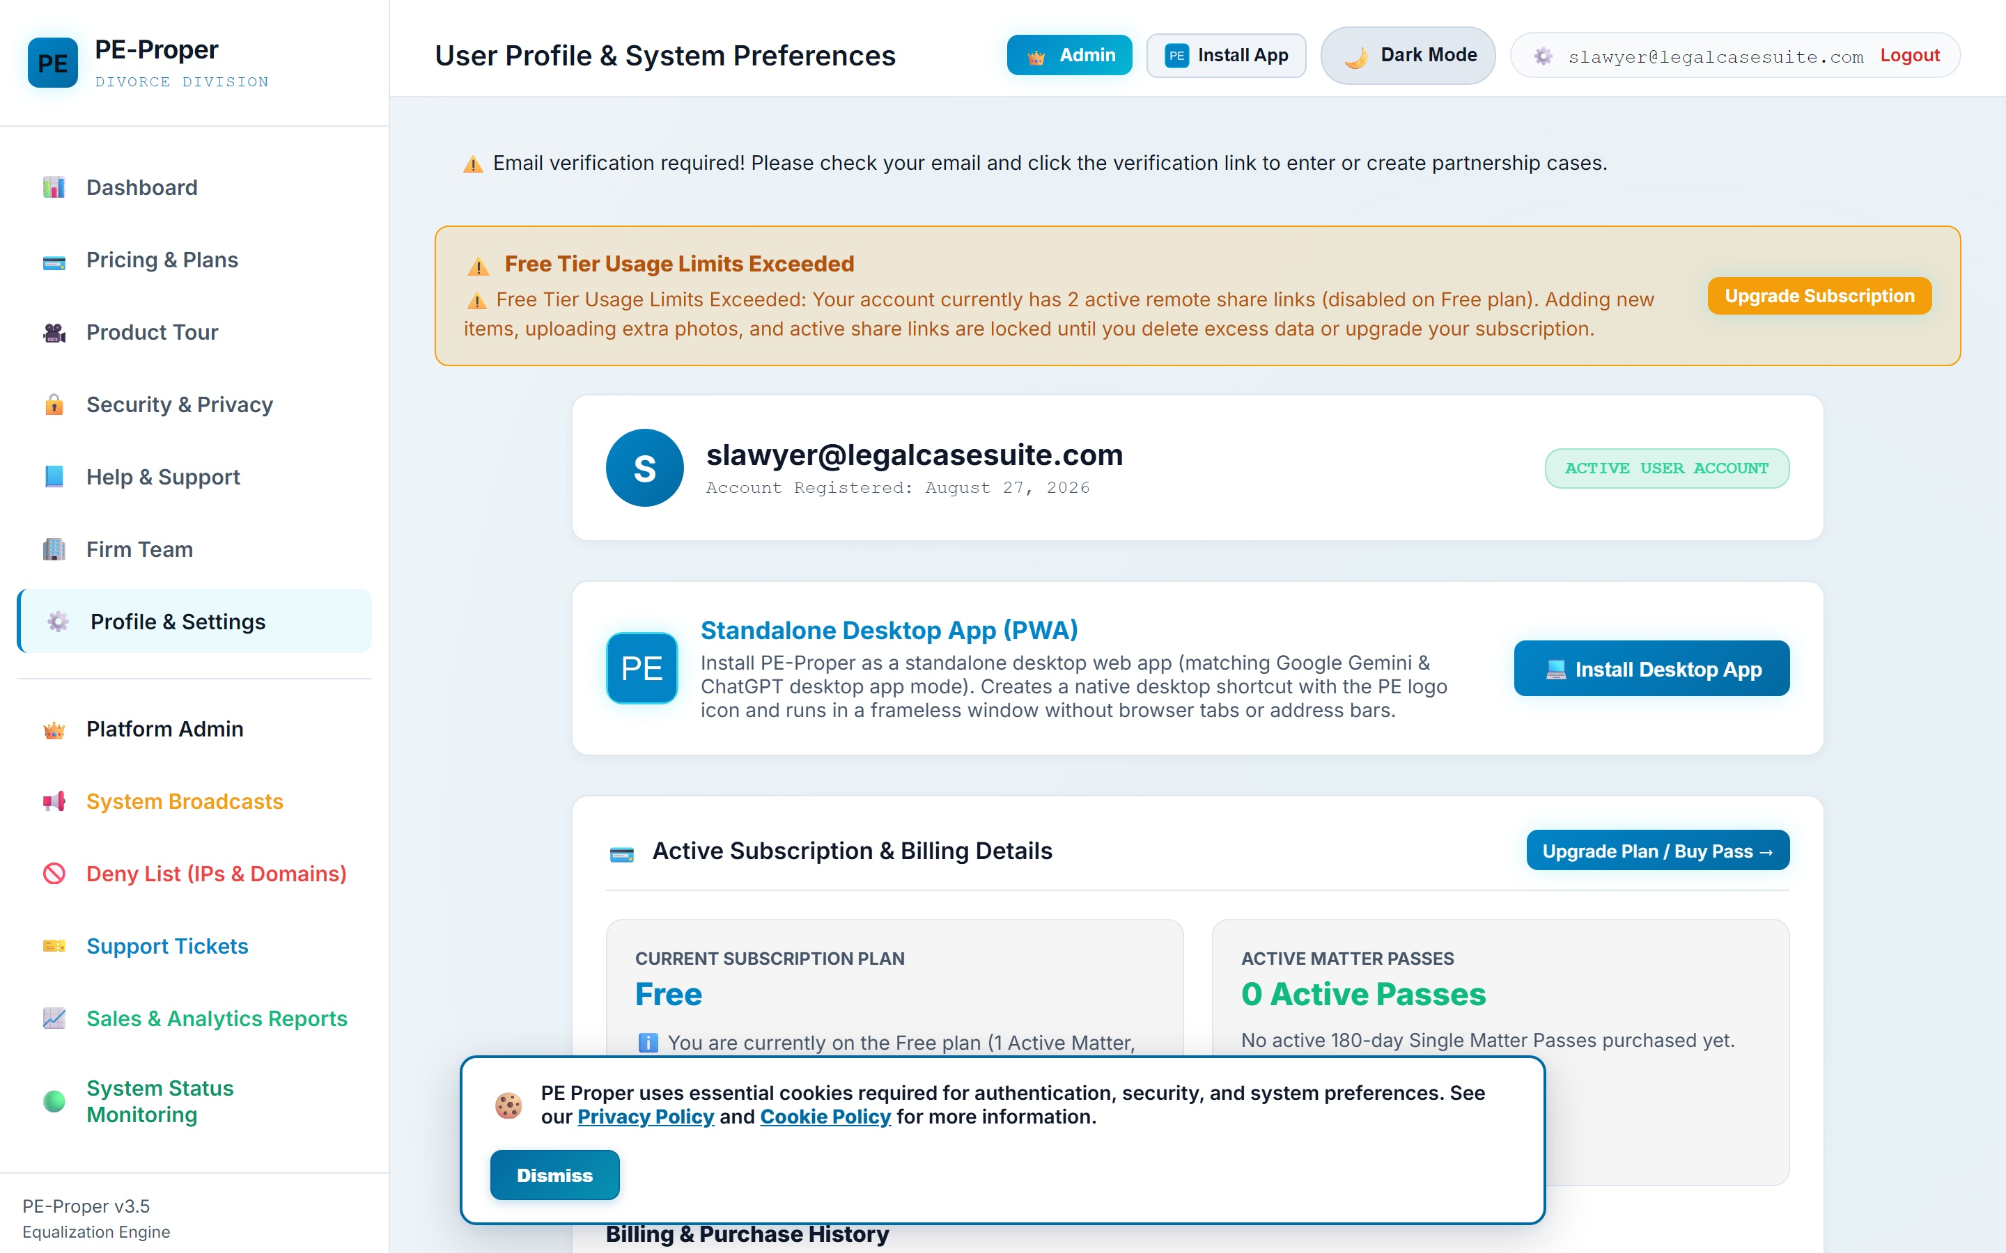
Fictional matter header and available case actions
Test outcome: 19 assets were entered successfully. PE Proper calculated $17,860 in current fair-market value and a $740 equalization payment from Julian Mercer to Elena Rossi-Mercer.

1. Executive assessment
PE Proper turns a difficult household-property conversation into a structured, auditable workflow. It combines intake, classification, valuation, possession decisions, statutory-style separate-property and gift treatment, negotiation simulation, collaboration, and professional property schedule in one focused application.
The strongest product story is not simply “make a list.” The product’s value is that every item becomes a decision record: what it is, when it was acquired, who acquired it, how it was funded, what it is worth now, what happens to it, and how that decision changes the equalization balance.
Bottom line: The application already demonstrates a credible end-to-end workflow for spouses, mediators, paralegals, and family-law professionals. The next marketing step should emphasize clarity, collaboration, and report readiness rather than broad legal claims.

Demonstration scenario
Spouse A: Julian Mercer. Spouse B: Elena Rossi-Mercer. Marriage date: October 12, 2018. Separation date: August 1, 2024. The relationship duration is approximately 5.8 years.
The matter includes two pre-marriage assets, two gifts assigned to Elena, fourteen community household purchases, and one jointly owned art collection designated for sale with proceeds split 50/50.
Demonstration outcome: 19 assets • $38,695 original purchase value • $17,860 current fair market value • $9,080 allocated to Julian • $8,780 allocated to Elena • $740 equalization payment from Julian to Elena.

2. What the hands-on workflow demonstrated

Create the matter once, then work from a single case workspace
The dashboard begins with a concise case form for both spouses, marriage and separation dates, case number, and court jurisdiction. After creation, the matter opens into a persistent workspace with collaboration links, calculations, reports, and the item register.

Cataloging is detailed enough for negotiation and reporting
Each property record supports an item number, description, category, original purchaser, purchase date, original price, FMV, possession or sale, funding percentages, gift status, transmutation treatment, condition notes, and up to three photographs.
The item-entry dialog captures classification, valuation, funding, disposition, notes, and photographs

The application recalculates the matter continuously
After each item was saved, the case totals, donut visualization, gift tally, separate-fund totals, spouse allocations, and draft equalization calculation updated without a separate calculation step.

Negotiation can be explored without changing the master allocation
The What-If Settlement Scenarios presents each asset with Spouse A, Spouse B, and Sell 50/50 choices. This is well suited to mediation because alternatives can be tested against the equalization balance before saving a named proposal.
The simulator opens with the master allocation and a $740 equalization balance

3. Feature assessment
Capability | Observed implementation
Case setup | Two spouse names, marriage and separation dates, case number, and jurisdiction create an immediately usable matter.
Collaborative intake | Assigned share links and QR codes support concurrent cataloging with role attribution.
Property classification | Category, purchaser, purchase date, funding percentages, gifts, transmutation, condition notes, and photos are captured in one record.
Valuation and allocation | Original price, current FMV, possession, sale proceeds, separate funds, and optional 50/50 comparison baseline are calculated together.
Negotiation | The What-If Settlement Scenarios allows live reassignment and sale scenarios without changing the master inventory.
Output | CSV, Excel, Google Docs-style report, encrypted backup, property schedule, thumbnail schedule, and full photo exhibit are offered.
Governance | Audit history, revocable share links, legal disclaimers, privacy pages, system status, and profile controls reinforce professional use.

What worked especially well

The application maintains one continuous line of evidence
Dates, purchaser, funding, FMV, disposition, photographs, audit attribution, and export options remain connected to the same property record. That continuity is more defensible and more useful than maintaining separate spreadsheets, photo folders, and email threads.

The collaboration model is practical
Spouse-specific links and QR codes can be revoked. Items submitted through assigned links can be attributed to the participant, which supports remote inventory work while preserving an audit trail.

The exports match real professional handoffs
The case workspace offers an encrypted backup, formatted Excel, CSV, a Google Docs-style report, a standard property schedule, a thumbnail schedule, and a full photo exhibit. These outputs support negotiation, discovery preparation, attorney review, and filing preparation.
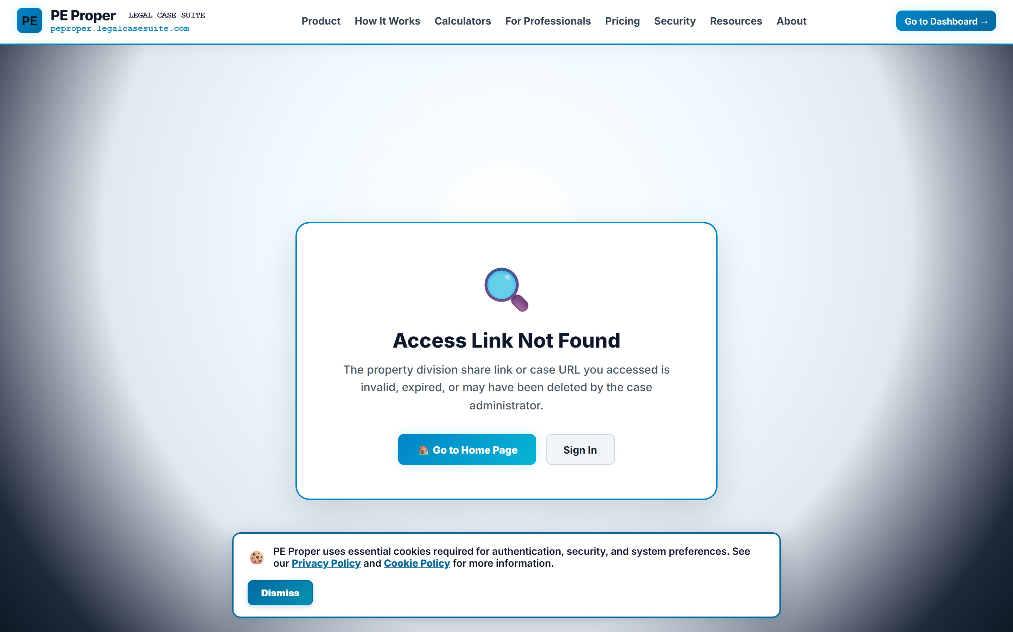
Generated Professional Property Schedule with equalization summary, case metrics, and itemized register

4. Product improvements revealed by the test

Explain the equalization formula directly beside the result
The screen showed $9,080 allocated to Julian and $8,780 allocated to Elena, yet the equalization payment was $740. The difference is driven by excluded gifts and separate-property treatment, but a user may initially expect the payment to be half of the $300 allocation difference. A compact formula disclosure would make the result immediately trustworthy.

Show exempt property in a separate awarded column
Pre-marriage assets and personal gifts displayed the correct possession decision, but the awarded-value columns showed $0 because the items were excluded from the community equalization base. Add “Separate/Gift Property Awarded” values or a visible exemption marker so possession and value do not appear contradictory.

Default the item register to item-number order
The register preserved entry sequence. Because a few items were added out of order during testing, #005 and #007 appeared before #004 and #006. Default numerical sorting would make the register and exports easier to audit.

Reduce horizontal table friction
The authenticated register contains many necessary columns and therefore scrolls horizontally on desktop. Consider a summary row with expandable details, or freeze the item number and description columns while scrolling.

Use careful security language
The public site uses the phrase “bank-grade security.” Marketing should prefer specific, verifiable claims such as password hashing, data isolation, revocable share tokens, encrypted backup, EXIF location stripping, and session controls.

5. Marketing foundation

Core positioning
Positioning statement: PE Proper helps separating couples and family-law professionals inventory, value, allocate, and document personal property in one secure, collaborative matter - with automatic equalization and professional property schedule reporting.

Homepage hero
Divide the property. See the balance. Document the agreement.
Build a complete household inventory, assign every item, test settlement options, and generate professional schedules without wrestling with disconnected spreadsheets and photo folders.
Primary call to action: Start a Free Matter. Secondary call to action: Watch the Two-Minute Tour.

Thirty-second product pitch
PE Proper gives each property item a complete record - description, photo, purchaser, date, funding source, current value, and final disposition. Spouses can catalog concurrently from a phone, mediators can test trades in real time, and legal professionals can export a clean property schedule, spreadsheet, or photo exhibit. The equalization engine keeps the financial balance visible throughout the process.

Feature pillars

Capture together
Assigned links and mobile QR entry let both spouses or professional participants document items concurrently with attribution.

Classify correctly
Separate funds, community funds, gifts, transmutation, purchase history, and current value stay attached to each item.

Negotiate visually
Live allocation totals, analytics, and the What-If Settlement Scenarios make tradeoffs visible before an agreement is saved.

Export professionally
Court schedules, spreadsheets, document reports, photo thumbnails, full exhibits, and encrypted backups move the matter forward.

Audience-specific messaging
Audience | Problem | Message
Separating spouses | A stressful, disputed household inventory | Create one shared record, make possession decisions, and see the financial balance change.
Mediators | Slow manual trades and spreadsheet recalculation | Test allocation scenarios live while preserving the original case record.
Attorneys and paralegals | Incomplete inventories and scattered evidence | Receive a structured register with photos, values, audit history, and court-oriented exports.
Law firms | Inconsistent matter intake and team handoffs | Standardize personal-property matters with reusable workflows, roles, organization, and reporting.

Recommended claims hierarchy
Lead with: organized property inventory, automatic equalization, collaborative mobile capture, mediation simulation, and professional exports.
Support with: separate-property funding fields, gift treatment, revocable links, audit attribution, encrypted backup, EXIF location stripping, and multiple report formats.
Qualify clearly: PE Proper is software for property organization and financial calculation. It is not a law firm and does not provide legal advice.

6. Recommended two-minute tour narrative
Time | Scene | Narration
0:00-0:12 | Open with the problem | Dividing household property is not only about listing belongings; every item affects the financial balance and the final agreement.
0:12-0:25 | Create the matter | Enter the spouses, marriage and separation dates, case number, and court.
0:25-0:42 | Invite participants | Use assigned links or QR codes so each spouse or professional can catalog from a phone or computer.
0:42-1:02 | Add complete property records | Capture description, category, purchaser, date, original price, FMV, funding, disposition, notes, and photographs.
1:02-1:18 | See the live balance | Watch values, gifts, separate funds, allocations, and the equalization payment update.
1:18-1:34 | Test settlement options | Trade items or sell them 50/50 in the What-If Settlement Scenarios without changing the master record.
1:34-1:50 | Generate professional outputs | Open the property schedule, photo exhibit, spreadsheet, document report, or encrypted backup.
1:50-2:00 | Close with the outcome | One organized matter. One visible balance. A clearer path to agreement.

Appendix A - Fictional 19-item property inventory
All names, values, purchase histories, and property descriptions are fictional and were created solely to demonstrate PE Proper.
# | Asset | Date | Buyer | Original | FMV | Result | Funding / condition
#001 | Harbor & Pine Vintage Walnut Writing Desk | 2017-04-22 | Spouse B | $1,200 | $850 | Spouse B | A 0.0% | B 100.0% | Community 0.0%  Elena's pre-marriage desk; very good condition with minor edge wear
#002 | Trek Domane SL 5 Road Bicycle | 2016-08-14 | Spouse A | $1,800 | $700 | Spouse A | A 100.0% | B 0.0% | Community 0.0%  Julian's pre-marriage bicycle; serviced in 2024
#003 | KitchenAid Artisan Stand Mixer with Attachments | 2018-10-20 | Gift | $0 | $280 | Spouse B | A 0.0% | B 0.0% | Community 100.0%  Wedding gift from Elena's aunt; cobalt blue
#004 | LG 65-inch OLED Television and Soundbar | 2019-02-10 | Both | $2,600 | $650 | Spouse A | A 0.0% | B 0.0% | Community 100.0%  Living-room television; excellent picture; includes wall mount
#005 | West Elm Harmony Three-Piece Sectional Sofa | 2019-05-18 | Spouse B | $3,400 | $1,250 | Spouse B | A 0.0% | B 0.0% | Community 100.0%  Performance velvet; light wear on chaise
#006 | Breville Barista Touch Espresso Machine | 2019-11-23 | Spouse A | $1,100 | $480 | Spouse A | A 0.0% | B 0.0% | Community 100.0%  Includes grinder accessories and stainless milk pitcher
#007 | Canon EOS R Mirrorless Camera Travel Kit | 2020-03-12 | Spouse A | $3,200 | $1,650 | Spouse A | A 0.0% | B 0.0% | Community 100.0%  Camera body, 24-105mm lens, flash, bag, and two batteries
#008 | Peloton Bike Plus with Floor Mat and Weights | 2020-12-04 | Spouse B | $2,495 | $900 | Spouse B | A 0.0% | B 0.0% | Community 100.0%  Operational; subscription not included
#009 | Weber Genesis II Gas Grill and Cover | 2021-04-30 | Both | $1,200 | $500 | Spouse A | A 0.0% | B 0.0% | Community 100.0%  Four-burner stainless grill; normal exterior weathering
#010 | Saffron House Hand-Knotted Wool Area Rug | 2021-08-21 | Spouse B | $2,900 | $1,400 | Spouse B | A 0.0% | B 0.0% | Community 100.0%  9-by-12-foot Persian-inspired rug; professionally cleaned
#011 | Apple MacBook Pro 16-inch with Dock | 2022-01-14 | Spouse A | $2,800 | $1,200 | Spouse A | A 0.0% | B 0.0% | Community 100.0%  M1 Pro model; includes charger, dock, and sleeve
#012 | Oak & Iron Extension Dining Table with Six Chairs | 2022-06-03 | Both | $3,600 | $1,800 | Spouse B | A 0.0% | B 0.0% | Community 100.0%  Seats six to ten; one chair has a repaired spindle
#013 | Roborock S7 MaxV Ultra Robot Vacuum | 2022-11-25 | Spouse A | $1,400 | $500 | Spouse A | A 0.0% | B 0.0% | Community 100.0%  Includes self-emptying and mop-cleaning dock
#014 | Avocado King Mattress and Thuma Walnut Bed Frame | 2023-02-18 | Both | $4,200 | $900 | Spouse B | A 0.0% | B 0.0% | Community 100.0%  Mattress and solid-wood platform frame; linens excluded
#015 | DeWalt 20V MAX Cordless Workshop Collection | 2023-05-07 | Spouse A | $1,900 | $1,100 | Spouse A | A 0.0% | B 0.0% | Community 100.0%  Drill, impact driver, saws, sander, six batteries, and rolling cases
#016 | Waterford Lismore Crystal Barware Collection | 2023-06-16 | Gift | $0 | $750 | Spouse B | A 0.0% | B 100.0% | Community 0.0%  Gift to Elena from her mother; twelve glasses and two decanters
#017 | Sony PlayStation 5 and PlayStation VR2 Bundle | 2023-09-22 | Spouse A | $1,150 | $700 | Spouse A | A 0.0% | B 0.0% | Community 100.0%  Two controllers, VR2 headset, charging dock, and six games
#018 | Sierra Clay Studio Art Pottery Collection | 2024-01-27 | Both | $2,100 | $1,300 | Sell | A 0.0% | B 0.0% | Community 100.0%  Nine signed contemporary vessels; sell through local gallery
#019 | EGO Power Plus Battery Lawn Equipment Set | 2024-04-19 | Both | $1,650 | $950 | Spouse A | A 0.0% | B 0.0% | Community 100.0%  Mower, string trimmer, blower, two batteries, and rapid charger

